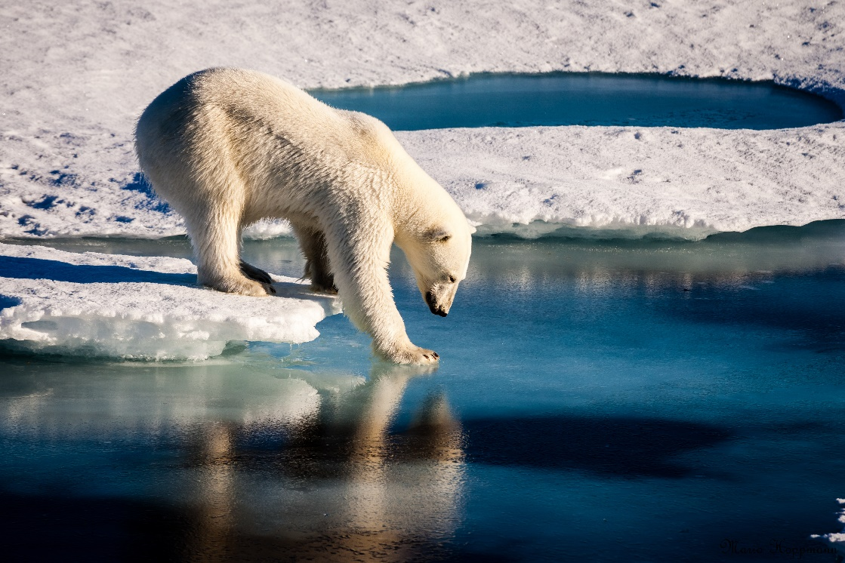

**______________________________________________________________________**

**Effects of the Arctic Ice Caps Melting on the**

**Spheres of the Earth**

Maxwell Nielsen

January 9, 2018

Science 9

Ms. Prosperi-Porta

Heritage Woods Secondary School

**Introduction to the Arctic Ice Cap**

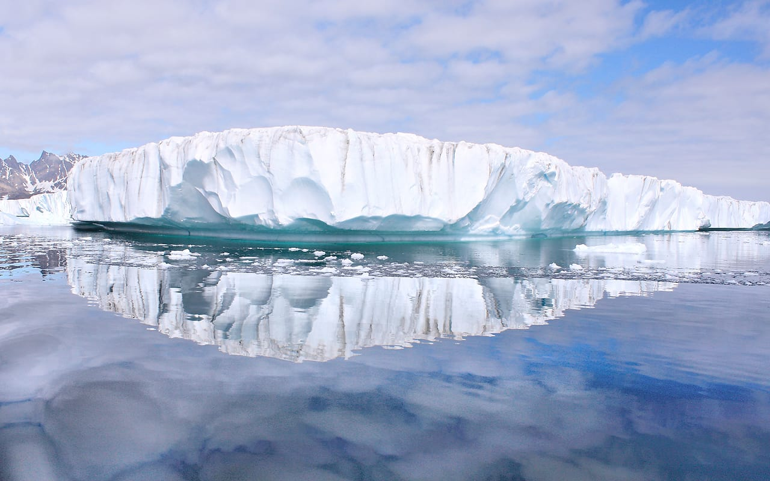**What is an ice cap?**

Ice caps are simply multiple layers of ice sheets covering a large area in both poles. Because the poles get very little precipitation and are the farthest to the sun, they can be created. They are usually found in high elevations in mountain ranges around the world and at both poles of the earth floating on the water. They cover more than 50,000 km2 in the Arctic.

**How do ice caps form?**

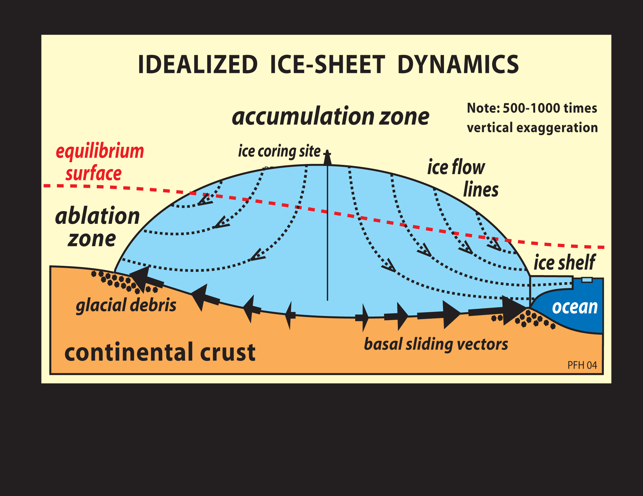

Ice caps form when regions receive more snow in a year than it loses in a year. A top of an ice cap (or the center of the ice cap for the polar ice caps) is the accumulation zone, where most of the snow for the year is collected. Every year, more snow is collected in layers, causing it to increase in density and cause it to become coarse, granular snow. This snow is then transformed into glacier ice. Lower elevations on ice caps are the ablation zones, where more ice is melted then snow is accumulated. This zone reappears every winter and usually is gone by the end of spring. This zone is due to warmer temperatures.

**Why are the Arctic ice caps melting?**

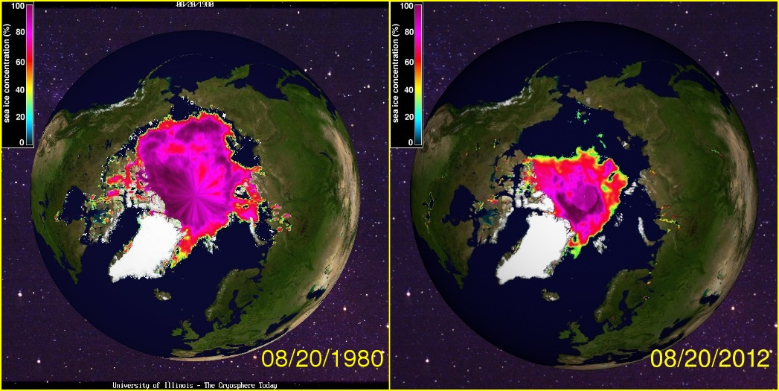To put it simply the ice caps are melting due to climate change. The temperature all over the world is rising, making the Arctic ice cap’s ablation zone bigger and the accumulation zone smaller. More CO2 is being released into the atmosphere, warming Earth and everything on it. As you can see in the image, since the start of studying the Arctic ice cap, it has gotten a lot smaller.

**Effects of the Melting Ice Caps- The Geosphere**

**How does it affect extraction of fossil fuels?**

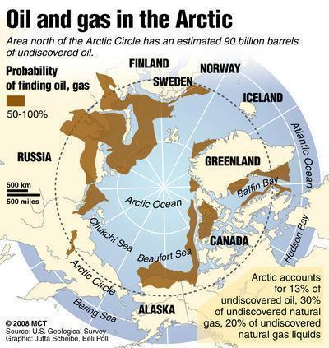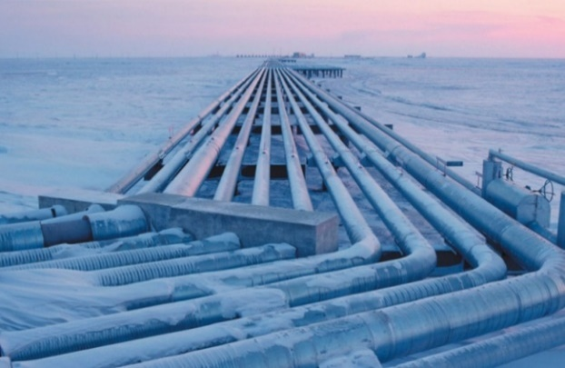The ice caps are increasing the profitability of fossil fuel and mineral extraction because there are more open waters to drill down to retrieve those resources. This will increase the profit of these companies. More and more companies are investing in drilling above the arctic circle because there are 22% of the world’s undiscovered natural resources just above the Arctic circle.

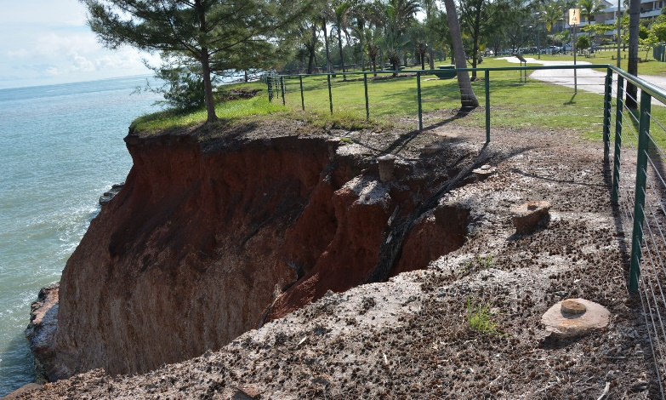**How does it affect the rate of erosion?**

Since melting ice caps lead to more rainfall in maritime climates, which leads to major erosion. This could create mud slide and other types of landslides in mountainous areas. It also will lead to major flooding in costal areas due to the low elevation. It will also lead to an extreme change in weather patterns as seen in recent years in Vancouver with hotter summers and colder, wetter winters than ever before.

**How does it affect the sustainability of the geosphere?**

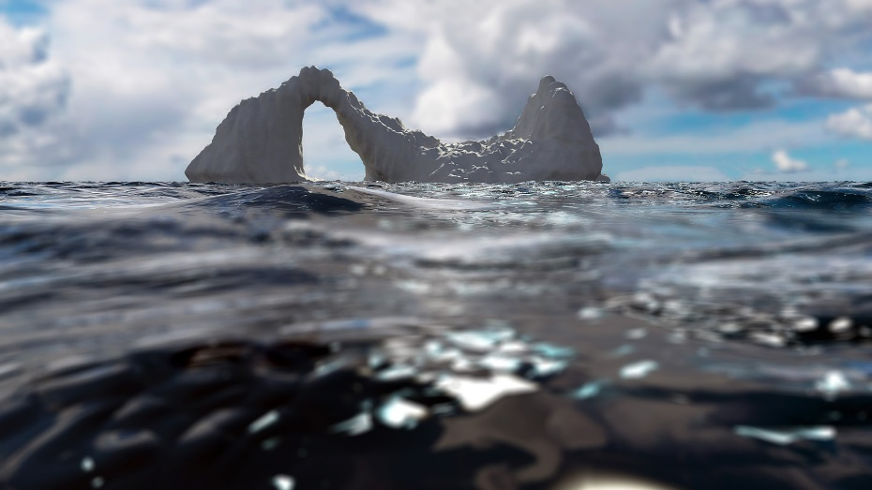The melting of the ice caps will not help the sustainability of the geosphere, because it will lead to more erosion than ever before, which will lead to mudslides and other landslides in mountainous areas. It will lead to warmer oceans, higher sea levels which will put most costal areas underwater. Lastly, it will release 1.7 trillion tons of carbon into the atmosphere, which would lead to global warming and more forest fires in dry continental climates.

**Effects of the Melting Ice Caps- The Atmosphere**

**How does it affect climate in other parts of the world?**

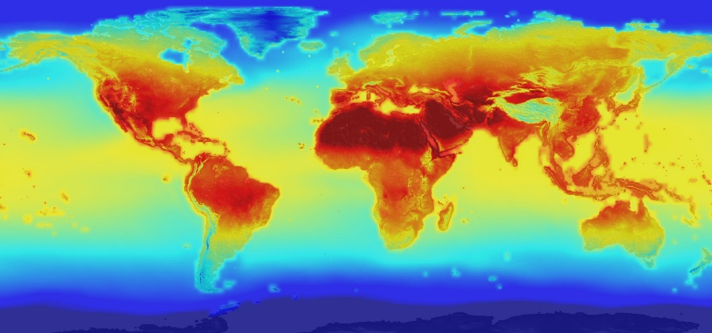

If all the Arctic ice cap melted, it would release 1.7 trillion tons of carbon raising the global temperature by 2C. Canada’s permafrost would release 55-560 billion tons of carbon, raising the global temperature by 0.5C by 2100. It will also raise the sea level by 20 feet. For example, in Kansas, raising the temperature by 2C would decrease the snow cover by 40% and would make it very hard to grow winter wheat and will reduce the soil moisture by 10%.

**How does it contribute to carbon in the atmosphere?**

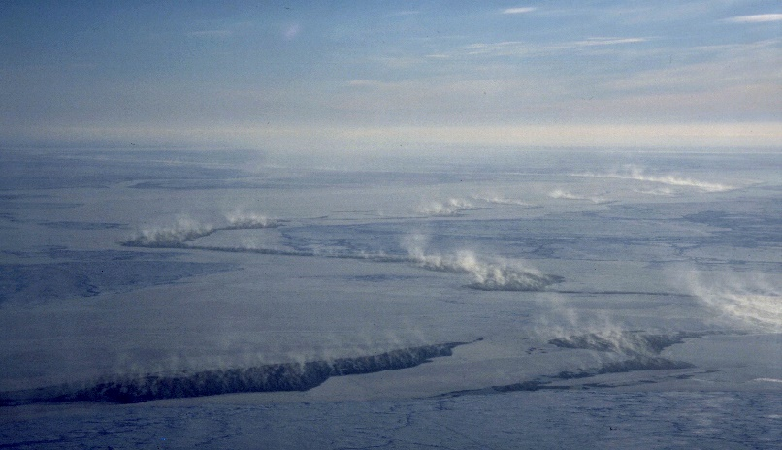

If the Arctic ice cap melted, it would release 1.7 trillion tons of carbon, heating the earth by 2C. There is also another 10 trillion tons of carbon on the seabed under the Arctic Ocean, inside crystalline structures called methane hydrates. Methane is 23x more potent than carbon dioxide, so it would basically mean the end of the world if that was released, but thankfully scientists think it would take a long time to release it.

**How does it affect the sustainability of the atmosphere?**

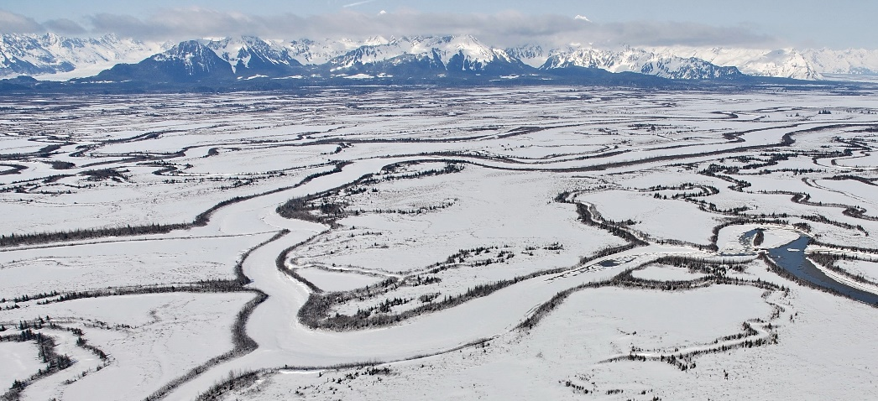The ice caps will ultimately end the sustainability of the atmosphere with that much carbon being released into the air from the ice caps. It will also raise the temperature in the atmosphere, making a lot of life forms extinct because they cannot adapt to the climate.

**Effects of the Melting Ice Caps- The Hydrosphere**

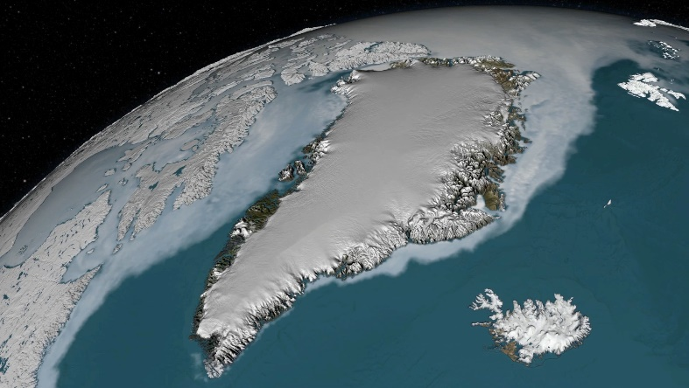**How does it affect the Greenland Ice Sheet?**

The ice caps in Greenland will be deeply affected by the Arctic ice cap. Because of rising waters, warmer waters, and it being more southern than the Arctic ice caps, the ice sheets will melt even faster in Greenland. This would raise the sea level by 23 feet.

**How will the Greenland Ice Sheet affect the hydrosphere?**

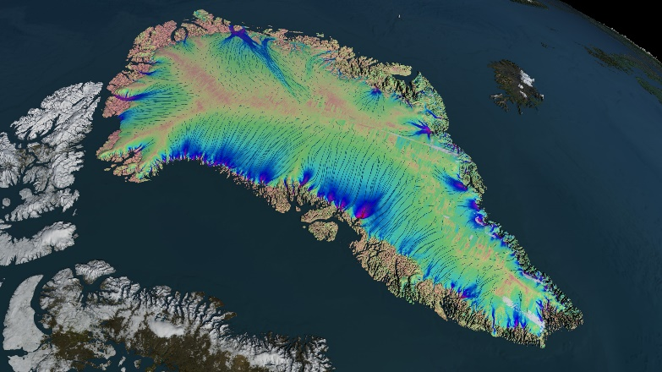

The ice caps in Greenland would raise the sea level by 23 feet and would contribute to the carbon emissions that are released from thawing permafrost.

**How does it affect the sustainability of the hydrosphere?**

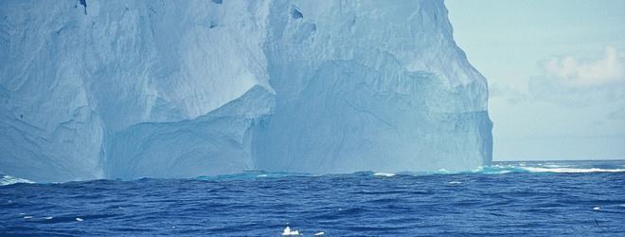

The ice caps melting will actually increase the sustainability of the hydrosphere because it will provide more water in the hydrosphere. But the melting ice caps provide fresh water, not salt water, so it will change the ecosystem in the Arctic Ocean.

**Effects of the Melting Ice Caps- The Biosphere**

**How have Arctic animals been affected?**

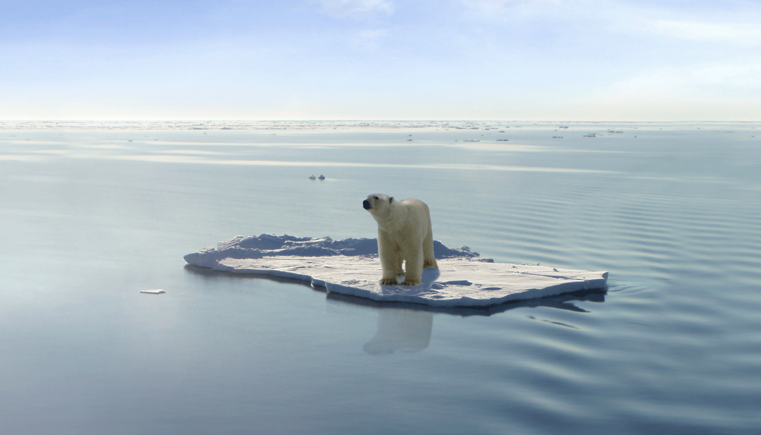**Polar Bears**

The polar bears will be the most affected species of animal because they rely solely on the ice the make them their homes. Already, all 19 subpopulations have been affected by shorter ice seasons in all ways (hunting, travelling, breeding). Seals are their main food, and they can’t live without it. With no ice, they would just die out since they can’t outswim any seal. They are losing 19 days of ice per decade now, and soon, the species will be extinct.

**Whales**

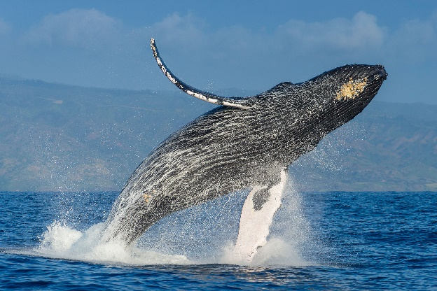The whales will also be affected by the ice cap melting with killer whales and orcas moving into the arctic to feed of other whale species because of the melting ice, they can go far north, and this is a problem for arctic whales. Without any ice, they would become more endangered than they already are because of a new predator. A new predator can change a whole ecosystem.

**Walruses**

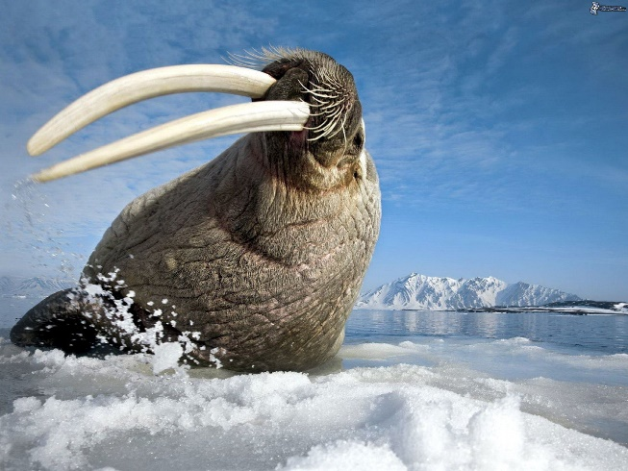The walruses in the arctic will almost be affected as much as polar bears because they constantly rely on the cold climate and the sea ice as their natural habitat. They spend half of their life on ice, so the melting of it will make some changes to walruses, and we don’t know if they can adapt to a no-ice environment. The melting will also stop any mating because ice plays a vital role in the reproduction of walruses. Also with a new predator around (killer whales and orcas) they must face new challenges and changing environments that they would be barely able to adapt.

**Seals**

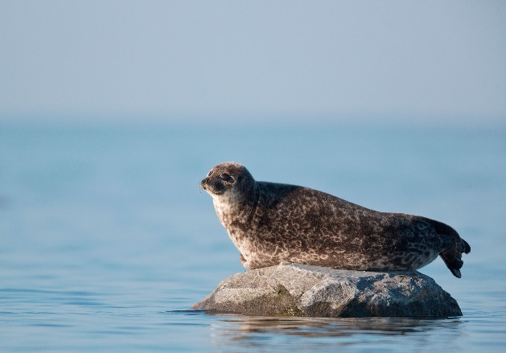Most seals will be greatly affected by it, but this is the only species that could not go extinct because of the melting of the arctic ice cap. Some seals rarely go on land, so those will be affected greatly. Though ice does provide a resting ground and some breed, feed and live on the ice, it shouldn’t be too hard on the seals compared to the other animals.

**Effects of the Melting Ice Caps- The Biosphere (Cont’d)**

**How does it affect hunting and fishing by the aboriginals?**

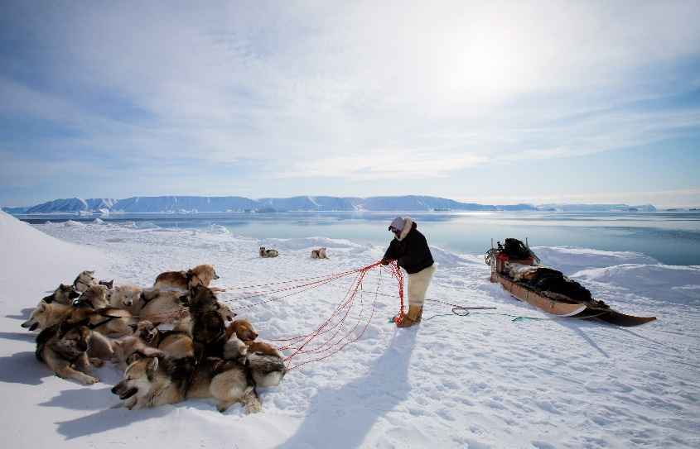The ice caps have greatly affected the arctic aboriginal’s hunting, safety and transportation. There is now thinner ice than ever before and it has already caused injuries and deaths of the aboriginals. They can no longer go fishing without being super careful of the ice underneath them. Hunting is also a problem because now their major food sources have moved, but the aboriginals haven’t. They’ve also had more severe storms than ever before. This is a terrible time for the arctic aboriginals to live in, and if the arctic sea ice melts completely, then it will be all over for living in the arctic.

**How does it affect the sustainability of the biosphere?**

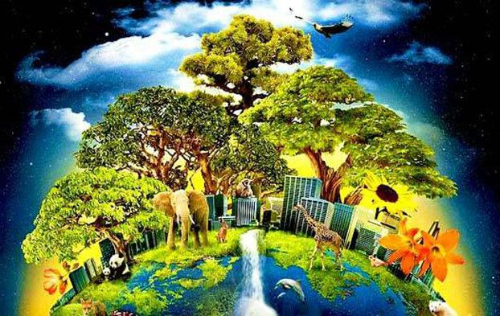

The sustainability will be affected in a negative way because multiple species will be extinct or extremely endangered because of the melt, and the aboriginal people will have no food, so they must relocate. The melting would destroy a whole ecosystem, but the cycle of life would continue.

**Analyzing and Interpreting the Melting Ice Caps**

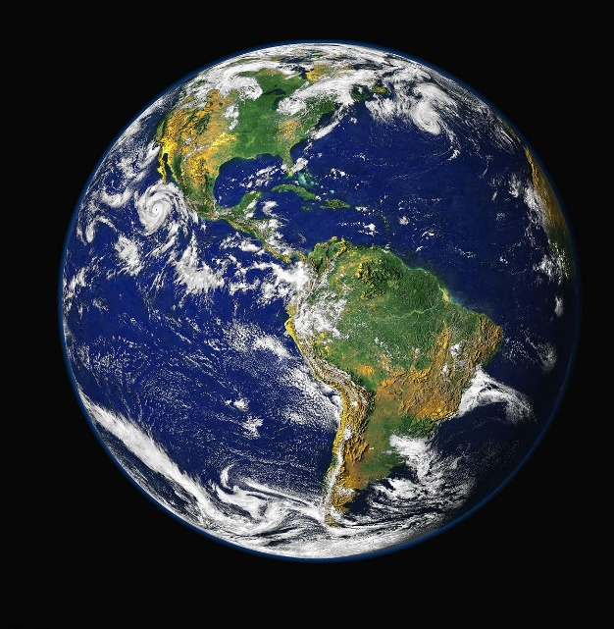**How does it show that all of Earth’s spheres are interconnected?**

The ice caps show that all spheres are interconnect because every sphere is affected by only some melting ice. All of the melting is affecting at least on thing in each sphere. Also, cause and effect. There is a lot of cause and effect that connect each sphere together. For example, since the ice caps are releasing so much carbon and it’s causing global warming, animals are settling in areas that they could not a decade ago due to the temperature and climate there.

**Are the melting Arctic ice caps considered a global problem?**

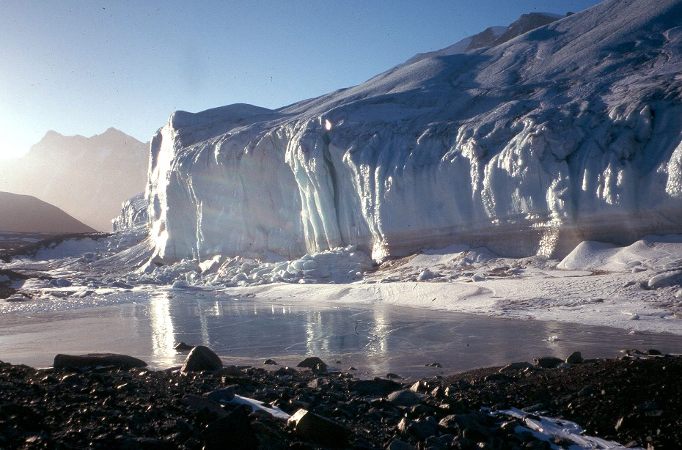The Arctic ice caps show clear evidence that it’s affecting the whole globe, with flooding in multiple low-lying cities around the world that is linked to sea level increases. Since the ice caps are releasing carbon and is scientifically linked to global warming, it’s also contributing to the global temperature rise. And if the predictions are true that the world will rise 2C just because of the ice caps, more places in the world could become uninhabitable.